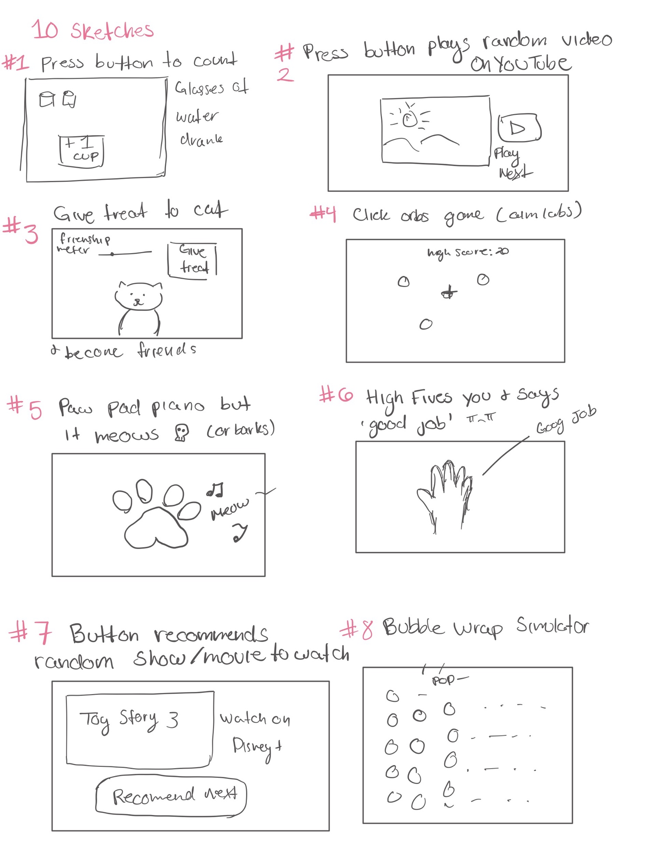

10 sketch write up:

To start the project off, each team member was tasked with creating 10 concept sketches each. For this project, the main idea was a button.

#1

My first sketch is a simple button that counts how many cups of water you drink a day. Each button press will add 1 cup to the tally, the longer you hold the button, the more that the cup gets filled. At the end of the day, a user would end up with a tally of how many cups they have drank.

#2

The second sketch idea plays a random YouTube video each time the button is pressed.

#3

The third sketch idea is a very simplified pet friend simulator. Each time the button is pressed, a treat is given to the cat. You can also tap on the cat to give it pets. At the top of the page, there is a “friendship meter” that goes up after petting the cat or giving it a treat.

#4

My fourth sketch idea was based on a popular aim trainer called “Aim Labs”. It is a mini-game that is meant to help you get better at first person shooter games like Valorant or CS:GO. The game has a crosshair in the center of the screen. Periodically, an orb will pop up in the window and the player must tap on the orb before it fades. There will also be a high score displayed at the very top of the screen, that keeps track of how many orbs the user has managed to hit in a row (before the orb fades away).

#5

My fifth sketch idea is basically a cat piano (I really like cats). The buttons are the paw pads displayed on the screen, when pressed the button will make a “meow” sound at a certain key.

#6

My sixth sketch is a simple “high five” button. This application would be used with a touch pad (like on a smartphone or tablet) the button simply says “good job” after you touch it. (you can tell I was running out of ideas at this point)

#7

My seventh button idea was aimed to alleviate a personal problem I tend to run into. Often, I find myself wanting to watch something while I eat dinner, but I tend to struggle to find things to watch. I decided it might be cool to have an application that recommends a random show or movie to you, which eliminates the energy and time from having to find one yourself. What’s fun about the application is that you won’t really know that you’ll be getting, and you might get bad recommendations that you end up watching. Which is cool since I find it hard to get myself to watch “bad” movies.

#8

My eighth idea is based on how satisfying it is to pop bubble wrap. This idea would be executed to be used on a smartphone or tablet with haptic feedback. Each button will look like a bubble and when pressed, the button will generate some sort of haptic feedback and a popping sound and popping animation will also be played. The haptic feedback on the iPhone for example is very impressive and an application like this could work well on it.

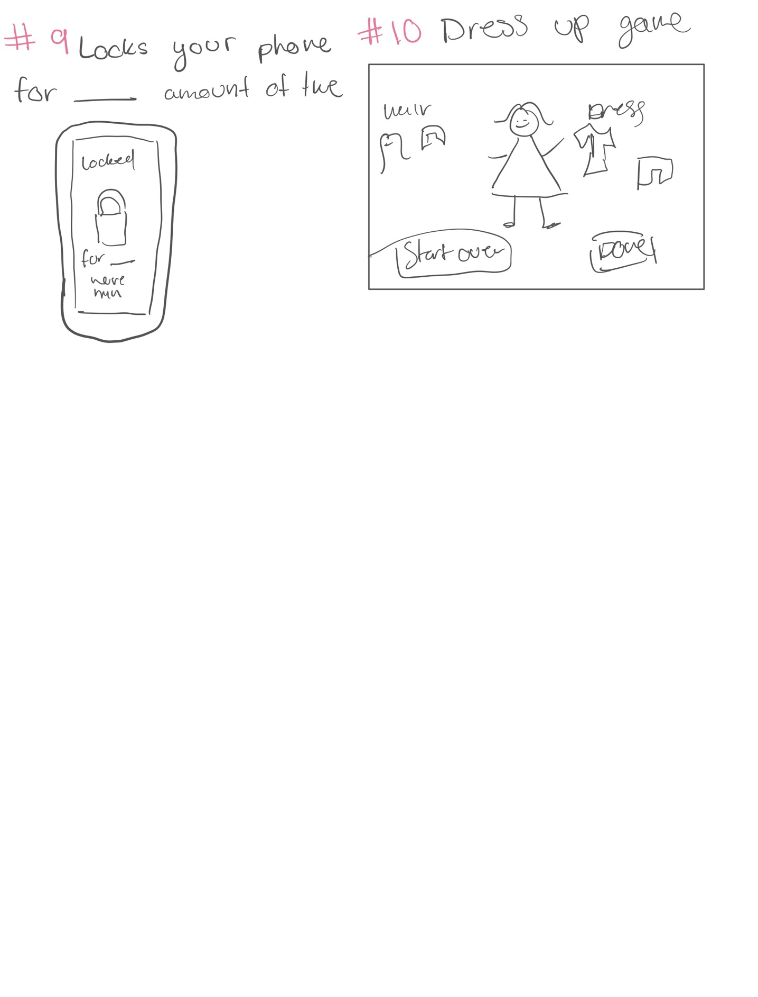

#9

My ninth idea is like other productivity apps that force you to be productive by limiting distractions coming from your phone. Here you have a simple button on the phone screen and when pressed, the phone gets locked making you unable to use the phone for a certain amount of time.

#10

My tenth and final idea is just a dress up game. Each piece of clothing is a button that once clicked will appear on the character.

For the next step of the project, my team and I discussed our ideas with one another and decided on which idea to do. We ended up going with my teammate’s idea. The idea was basically a way to time tasks and a way to make tasks more enjoyable with the help of music. The user would have buttons for different tasks, and each task would take a certain amount of time. For example, “brush teeth” will take 3 minutes and so on. When the user would press on the” brush teeth” button, the application would begin to play a song for the duration of the task. In this example, it would play a 3-minute song. With this project idea in mind, Each teammate was tasked with making 3 high detailed sketches on the project idea.

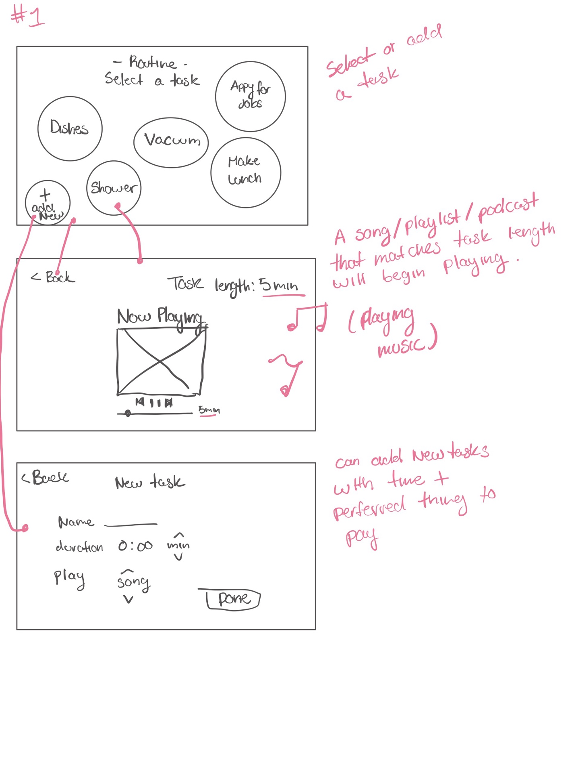

Detailed sketch #1:

My first detailed sketch is for a website. In the homepage, there are several task buttons. Each button will display the name of the task. The webpage will know how long

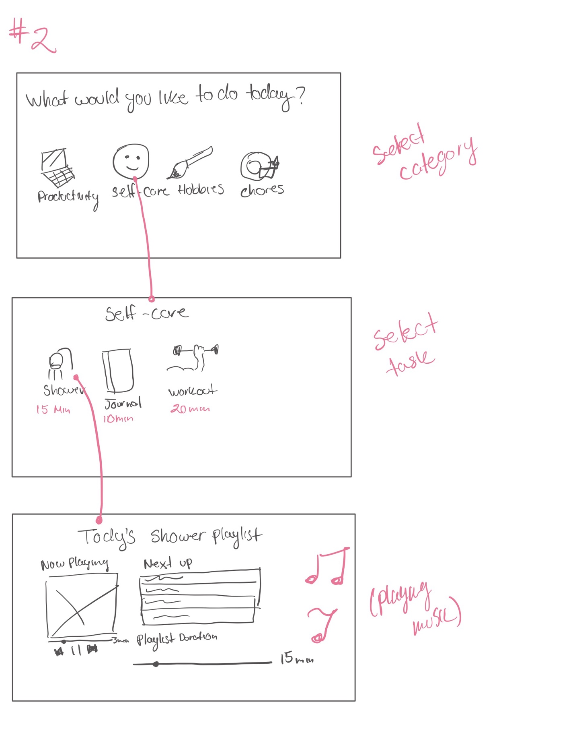

Detailed sketch #2:

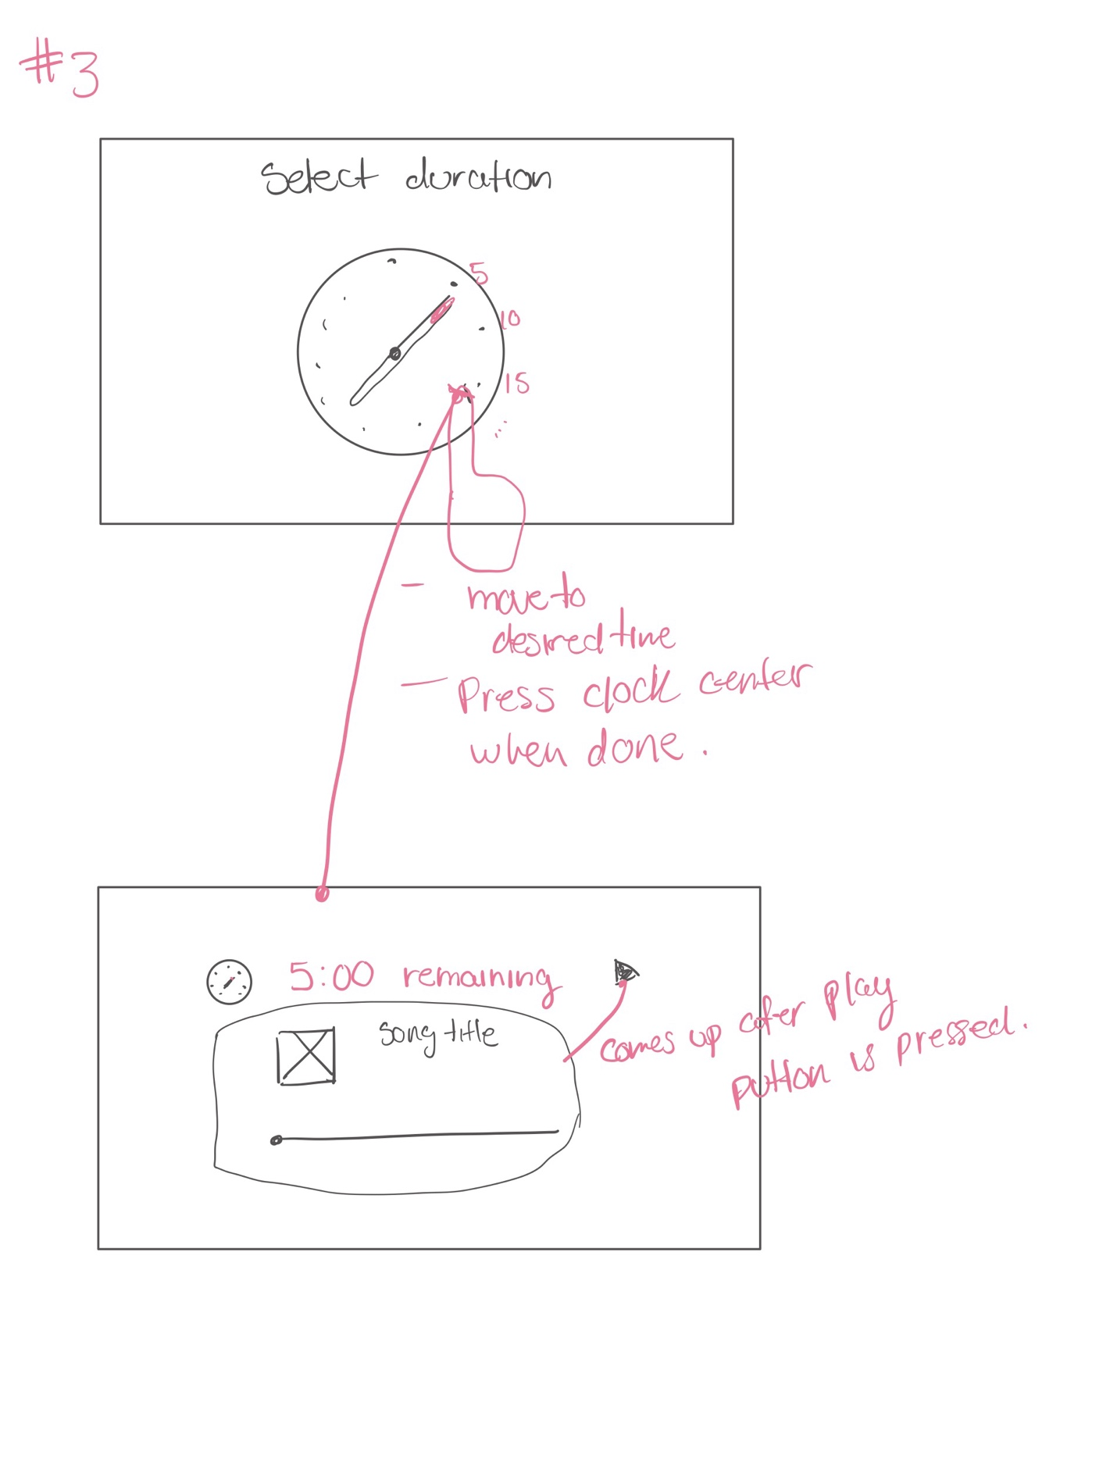

Detailed sketch #3: